

* Introduction to me

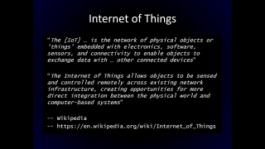

* Internet of Things
  + First Internet device - toaster in 1990 created by John Romkey, turn on/off over the internet
  + In 2000 L.G. announced its first Internet Refrigerator plans
  + Now we have everything online from people with heart monitors to pools to cars.

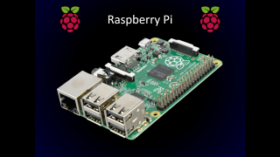

* Introduction to the Raspberry Pi
  + Fully functional computer the size of a credit card
  + Introduced in 2012
  + Intended to promote teaching basic computer science
  + Capable of running a number of flavors of Linux and Windows 10 IoT
  + Quick Google search turns up all kinds of creative ways people have used the Pi. Media centers, MAME arcade emulator, near-space-altitude web cam, garage door opener, BeetBox (musical instrument with Pi and beets!), brains for Roomba robot, sensor monitors, you name it.
  + Pool Pi

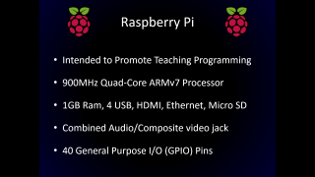

* Raspberry Pi Specs
  + Quirkiness of 3.5mm combined audio/composite video jack.
  + 4-pole jack – ground, left/right audio, video. Most cables have ground/video swapped from what the Pi wants.
* Introduction to Windows 10 IoT Core
  + GUI limited to … No console UI
  + Raspberry Pi 2
  + 8 Gb micro SD card
* Setting Up Development Environment
  + <http://ms-iot.github.io/content/en-US/win10/SetupPCRPI.htm>
  + PC running public release of Windows 10, at least build 10240 (start, winver, enter), micro SD card reader
  + Visual Studio Community 2015
    - <https://www.visualstudio.com/products/visual-studio-community-vs>
    - Make sure Universal Windows App Development Tools -> Tools and Windows SDK is checked.
  + Windows IoT Core Project Templates
    - <https://visualstudiogallery.msdn.microsoft.com/06507e74-41cf-47b2-b7fe-8a2624202d36>
* Installing Windows 10 IoT Core on the Pi
  + <http://ms-iot.github.io/content/en-US/win10/SetupRPI.htm>
  + 8GB micro SD card,
  + Download IOT Core RPi.ISO
  + Mount ISO and/or open it, run Windows_10_IoT_Core_RPi2.msi
    - Installs the Windows 10 IOT Core to C:\Program Files (x86)\Microsoft IoT\
    - IoT image is an FFU (Full Flash Update) file in the FFU\RaspberryPi2\ folder.
  + Insert micro SD card
  + Run IoTCoreImageHelper.exe, select SD card drive and FFU and flash.
  + “Safely Remove and Eject” the micro SD card.
  + Insert micro SD card in Pi, connect HDMI, Ethernet, mouse, keyboard, power cord.
  + Note IP address
* Setting Up Raspberry Pi using Powershell
  + <http://ms-iot.github.io/content/en-US/win10/samples/PowerShell.htm>
  + Connect to the Pi using PowerShell
    - net start WinRM //
  + Create a trusted relationship between your development PC and the Pi
    - Set-Item WSMan:\localhost\Client\TrustedHosts -Value <machine-name or IP Address>
  + Establish a connection to the Pi
    - Enter-PSSession -ComputerName <machine-name or IP Address> -Credential <machine-name or IP Address or localhost>\Administrator
      * p@ssw0rd
      * Up to 30 seconds
      * IP Address in prompt
  + Update Administrator password
    - net user Administrator [new password]
    - Exit-PSSession Enter-PSSession –Computer
      * For me, this left PowerShell in an invalid state and I had to close and reopen it, then re-establish the connection.
  + Ensure the Visual Studio Remote Debugger is running on the Pi by running tlist and making sure two instances of msvsmon.exe are running. Should start on boot. Could time out after long period of inactivity. Reboot Pi to restart.
  + Rename the Pi
    - setcomputername <new-name>
      * Reboot Pi
  + <http://ms-iot.github.io/content/en-US/win10/tools/CommandLineUtils.htm>
* Blinky
  + First time opening project in Visual Studio, prompted to “put device in Developer Mode  
    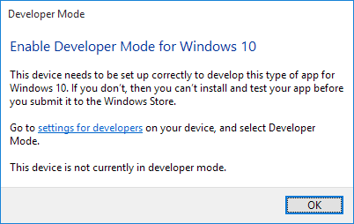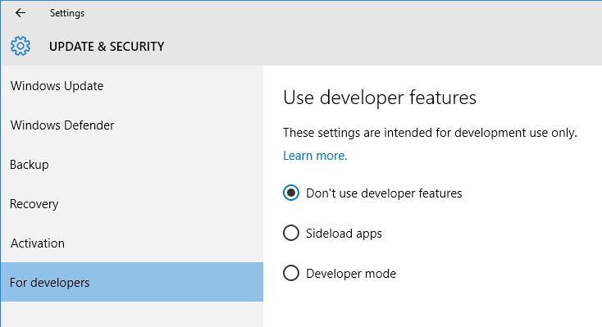  
    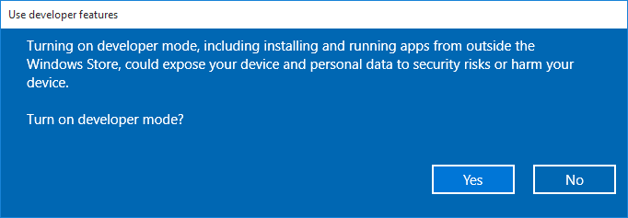
  + Compile project to pull in nugget packages
  + Solution Platforms dropdown – ARM
  + Device dropdown – Remote Machine
    - Pi name/IP, Auth=None
  + Build, F5
* Hello World
  + New project, Templates/Visual C#/Windows/Universal -> Blank App
  + Add Reference, Universal Windows/Extensions, Windows IoT Extensions for the UWP
* PyGlow